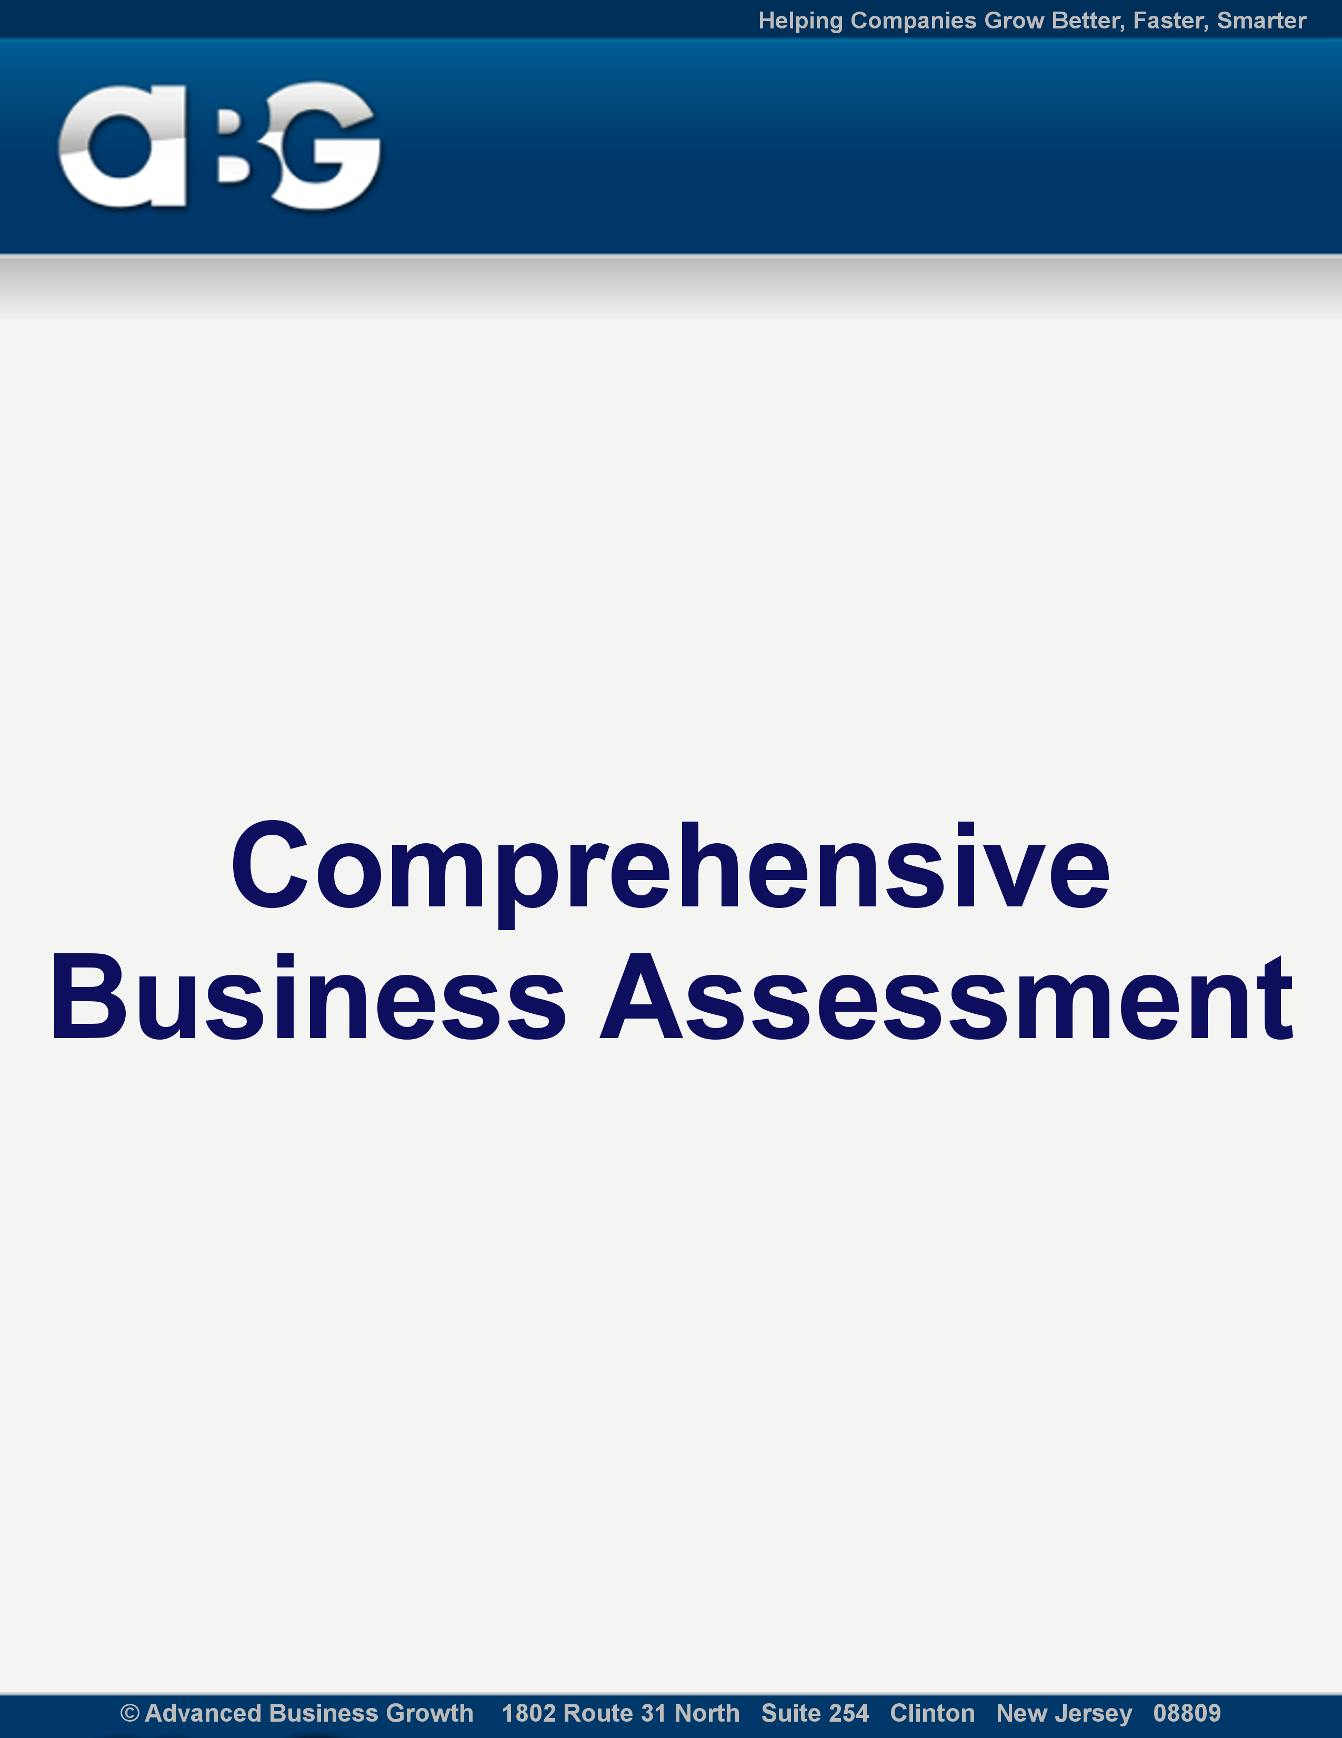

All the information provided on this form will be kept in the strictest confidence
and used exclusively for helping you achieve your business growth goals

The following information will help Chris, help you maximize your profit potential AND customize this program to your unique environment, business, values, available resources, experience, abilities and preferences.

Section #1- Company Overview
Place answers in the box along each question or statement
Company Name:

Years In Business:

Your Name:

Street Address:

City:

State:

Phone:

Cell:

Website:

Email:
Supporting staff and each of their main function(s):

Industry
What market are you in?

What are your primary product(s)/service(s)?:

Detailed Description (# each if more than one):

Price(s):

Competitive Advantage(s)
What makes your product/service unique? Better? Different?:

Market(s) Served
Geographic:

Segment(s) or niche:

Describe your Target Prospects (age, sex, lifestyle, income, fears, needs, etc):

Customer Profile
Number of Clients/Customers:

Active (How many do you consider ongoing clients)

Inactive (How many are lost clients or ones that will not reorder):

By Type (i.e. retail/business/age/industry etc.):

What percentage of your database do you have email addresses for?

What percentage of your database do you have physical mailing addresses for?

What percentage of your database do you have phone numbers for?

Profile of your top 20% of customers (why they buy more than others):

What annual revenue does your top customer produce for you:

What services/products do they order?:

Financial Model
Company Revenue:
-past 12 months revenue:
-projected 12 months revenue:
- List what your top revenue generators are:
Company Expenses:
-past 12 months revenue:
- projected 12 months revenue:
- List your main expenses are:
Gross Margin % (rev. less direct labor and product/materials and sales commissions:

Average Revenue per sale:

Average Annual Revenue Per Customer:

Lifetime Value (annual rev. X number of years a customer = $LTV):

Competition
List Top 3 Competitors and URL for each:
1)
2)
3)
Pricing vs. You:

Competitive Advantage(s) of each (what they do better than you):

Weakness(es): (competitors)

How do you fill void? How do you differentiate yourself from your competitors?:

Section #2 - New Customer Acquisition
Lead Generation
What are you primary source of leads (please describe each):

What prospect list(s) do you use?:

Marketing Tactics (please include % of revenue from each)
Direct Mail:

PPC and/or Banner Ads:

SEO:

Referrals:

Telemarketing:

Offline Paid Advertising:

Joint Ventures:

Trade Shows:

Public Relations and/or Branding:

Others (explain):

What has been your best marketing success to date?:

Do you currently have a prospect database?

Do you have your prospect database segmented?

Number of prospects in your database:

How often do you contact them? (via email, mail, phone, fax):

How often do you market to your database?

Please describe your database marketing below:

Do you currently utilize Compelling Incentives and Bonuses to lure new customers to talk to you, meet with you, or motivate them to purchase your products and services?:

If yes, please describe below:

What is the impact of these efforts?:

Do you currently offer Backends and Upsells to increase the LFT of your customers?:
If yes, please describe below:

What is the impact of these efforts?:

Do you currently package synergistic products or services to increase your average purchase?:

If yes, please describe below:

What is the impact of these efforts on your revenue and profit?:

Do you currently have Strategic Endorsement Partners (or Affiliates) that promote your products/services to their customers?:

If yes, briefly explain below:

Do you currently test new marketing campaigns and business changes before you roll them out?:

If yes, briefly explain below:

Do you currently utilize guarantees?:

If yes, briefly explain below:

How do you estimate these guarantees impact your revenue?:

Do you have a systematic template or process you use when developing marketing campaign copy?:

If yes, briefly explain below:

Do you track and monitor each of your marketing efforts?:

If yes, briefly explain below:

Section #3 - Your Sales Process

Please describe step-by-step your entire sales process below (lead generation, appointment, proposal, close, follow up):
Step 1
Step 2
Step 3
Step 4
Step 5
Please indicate for each area whether you feel that you are weak or strong:
Lead Generation:
Initial Contact:
Appointment Process:
Proposal Process:
Follow Up Process:
Closing Process:
Upsell Process:
Cross Sell Process:
Do you track:
- Leads to appointment %?
- Appointment (or Visits) to conversion %?

If yes, explain below:

What do you do with prospects who do not buy?

Number of outside sales reps:

Quota/Expectations:

Actual Performance:

Number of inside sales reps:

Quota/Expectations:

Actual Performance:

Section #4 – Internet Activity

Traffic
Number of visitors to site per week:

Number of UNIQUE visitors per week:

Average visits/visitor per week:

Average pages viewed per visit:

Average time on site/visit:

Number of monthly click-throughs from search engines like Google or Bing:

Do you use Search Engine Optimization?

If so explain:

Do you use Pay Per Click?

If so explain:

Do you have an Affiliate Program?

If so explain:

Revenue/Transactions
Number of sales per month- revenue and transactions:

Conversion Rates
Unique Visitor to Email Sign up?

Conversion rate of unique visitors to sale (%):

Conversion rate of Shopping Cart to sale (%):

Conversion Rate of Check out to sale?

Other:

Section #4 – Maximizing Customer Transactional Value

Do you currently and systematically offer customers additional products or services as add-ons at the point of purchase?:

If yes, what triggers the offer?:

What item(s) do you offer?:

What is the profit margin on these additional items?:

How many customers on average take advantage of the item offered?:

Do you have a “fallback” item that you offer prospects if they do not purchase the product/service you are promoting (i.e. don’t buy the swimming pool but you sell them a spa instead):

If yes, describe in detail below:

Do you currently follow up at set intervals to motivate your customers to re-purchase from you again?:

If yes, how often should they re-purchase from you?:

When do you follow up?:

What % re-purchase due to this follow up?:

Do you currently have a systematic Customer Satisfaction System that is followed?:

If yes, describe the system below:

Do you have a new customer program?:

If yes, describe the program below:

For how long does your average customer purchase from you?:

Do you currently have a systematic referral system(s) in place?:

If yes, describe the system below:

Do you currently have a systematic program in place for getting customers to buy other products/services you or someone else provides?:

If yes, briefly explain below:

What additional revenue and profit does this produce outside the primary or original purchase?:

How often do you contact your list?:

Reasons why: (educate, promote products/services, specials, request referrals, etc):

What medium do you use to communicate with them? (direct mail, phone, email, etc.):

Do you currently have Strategic Endorsement Partners where you promote their products/services to your customers?:

If yes briefly explain below:

Section #5 Management- Procedures and Systems
Do you currently have a systematic step-by-step way of implementing change or new procedures within your company?:

If so, briefly explain below:

How many hours per week do you work “on the business” developing marketing, sales or operational improvements?:

What are your top challenges that keep you from implementing change in your business (i.e. time, resources, capital, staff, etc)?:

Do you hold regular staff meetings?:

If so, what do you discuss?:

Do you have a set of standard reports that help you keep a handle on the critical business metrics?:

If yes, briefly explain below:

Do you have a set of standard reports that help you keep a handle on the critical business metrics?:

If yes, briefly explain below:

Do you struggle with “Time Management”?:

How many hours do you average per week?:

Do you have written policies and procedures?:

If yes, briefly explain below:

Are the critical “knowledge” processes in written form? That is, have you captured the best practices for sales marketing, customer service, delivery, operations, etc. in writing (so that they do not leave when someone critical leaves)?:

If yes, briefly explain below:

Do you prioritize the most important projects and task and work on them in that order?:

If yes, briefly explain below:

Section 6 - Your Goals from this Coaching Program
What would you like to accomplish through this coaching program? (i.e. grow your customer base, increased your revenues/profits, attract higher-level staff, increase management effectiveness, increase customer satisfaction and longevity, reduce turnover, create a systematic, sellable business operation, growth through acquisition of other companies, reduce the hours you spend at work) Please give as much detail as possible below:

Biggest Current Challenges (i.e. lead generation, sales, manufacturing, time, capital, sales channels, marketing, competition, expertise, management, staffing, etc):

Top Opportunities (i.e. potential revenue increasers, new markets, new products/services, new channels):

Additional Information: Is there any additional information you would like to share about yourself or your business that will help us better understand you and your business?:

Congratulations! You have just completed the first step in reaching your goals with the Advanced Business Growth Program, take a moment and celebrate!

All the information provided on this form will be kept in the strictest confidence
and used exclusively for helping you achieve your business growth goals.

Immediately save this document to your hard drive as “yourcompanyname_ABG.doc” and when you have completed it simply email it to: Emily@AdvancedBusinessGrowth.com.

